* **Install NetBean step by step**
  + Link to get Netbean: [http://www.enterprisedb.com/products-services-training/pgdownload](https://netbeans.org/downloads/)
    - Please choose Java EE
  + You need JDK in order for Netbean to run. Link to JDK: <http://www.oracle.com/technetwork/java/javase/downloads/jdk8-downloads-2133151.html>
  + Double click on the installer file, an installation wizard will appear and guide you through installing. Please choose to install GlassFish serve and have the port at 8080
* **Clone Github project**
  + Open Netbean,click Team,Remote,Clone
    - 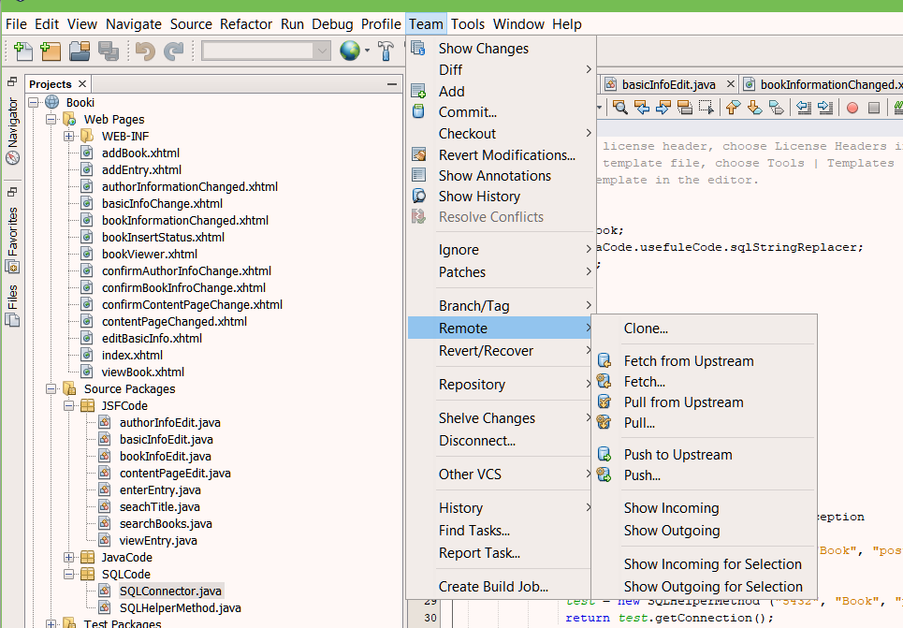
  + You will see the following window. The Repository URL could be found by clicking Clone on Github as shown below. (I am not quite sure if user and password are need to clone, if it is please get a github account) and press next:
    - 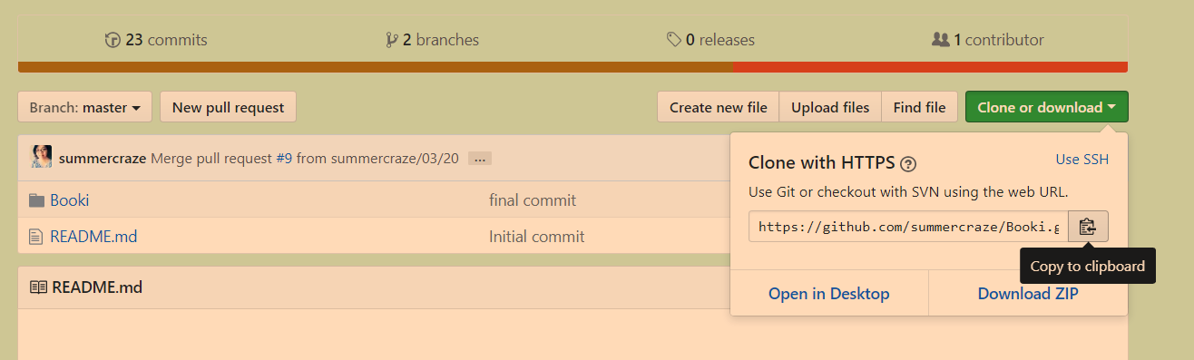
    - 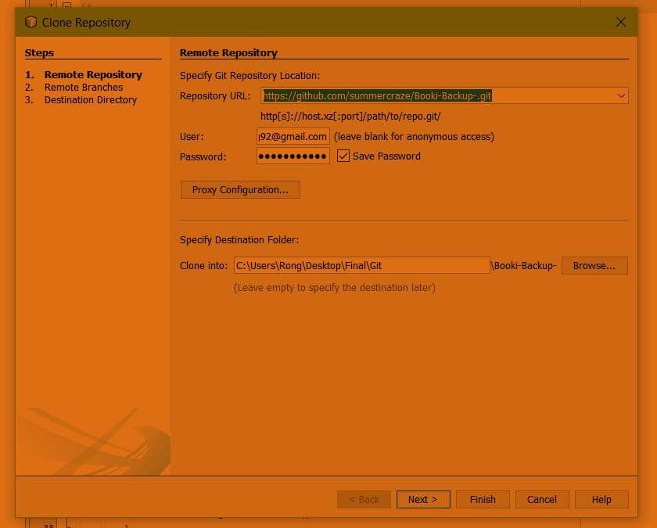
  + Follow the rest and you should be able to successfully clone repository.
* **Install JDBC Driver**
  + In order to run the Database in NetBean, a JDBC driver needs to be installed in the NetBean library. The following is the manual for installing the library
  + Install the JDBC drive from the following link(<https://jdbc.postgresql.org/download.html>)
    - Note: Download is under current version
  + Open Netbean, click on the project and find the directory Libraries, left click and click add Library to add PostgreSQL JDBC Driver
  + And left click again to JAR folder to add postgresql.jar.
  + Your library should look like the following:
    - 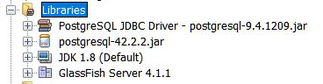

* **Connecting to the database**
  + This is the step to connect to the database
  + Under the Source Package, there is a Package name SQLCode and a code named SQLConnector
  + Check that the variable test under the method connect() (Highlighted in the picture) is filled with correct port number, Database name , username of the database, and password. If not, you should change the string with the right information
    - 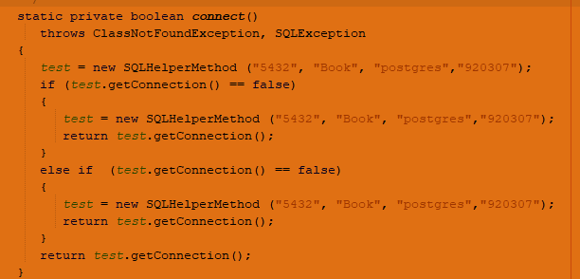
  + You are all set, enjoy the application!